GEOL 551: Applied Petroleum Geology   
Assignment #8 - Due 4/8/2019

Nadima Dwihusna

**Homework Task**

* Pick other faults in the Niobrara Interval
* Pick base of Niobrara then make thickness map of Niobrara

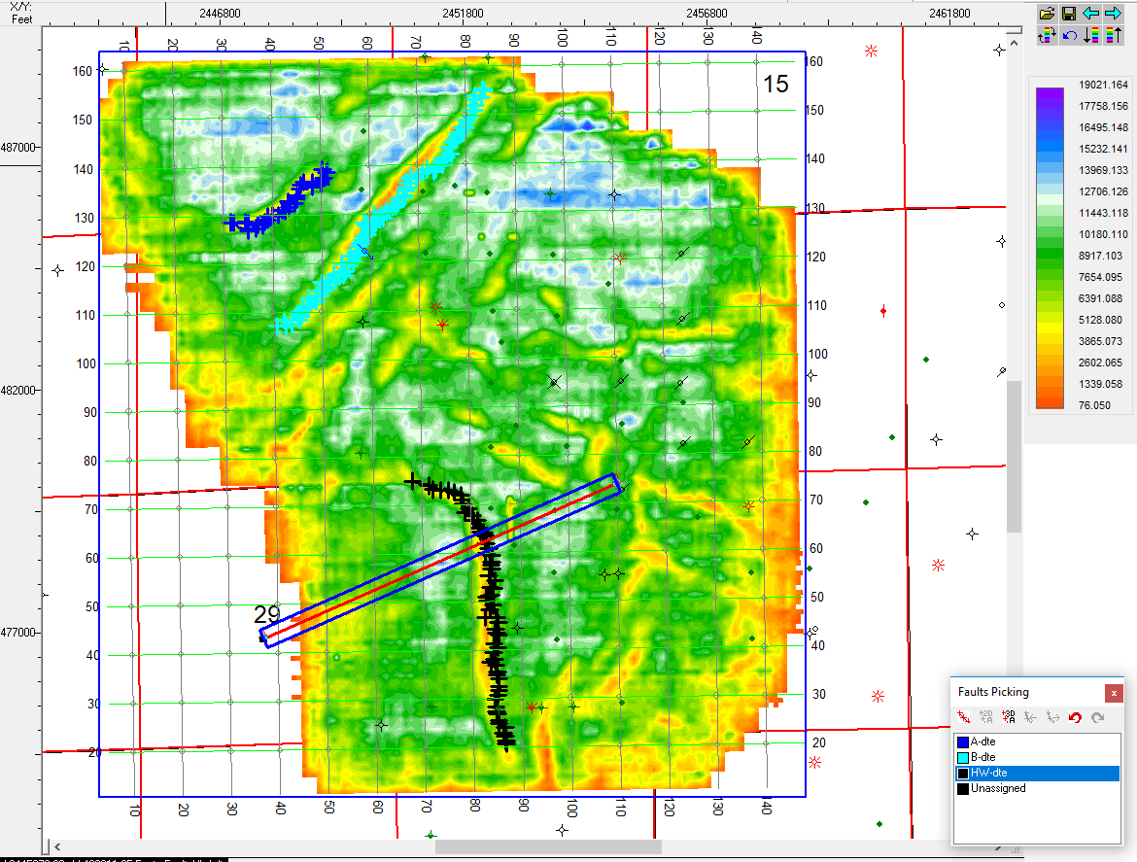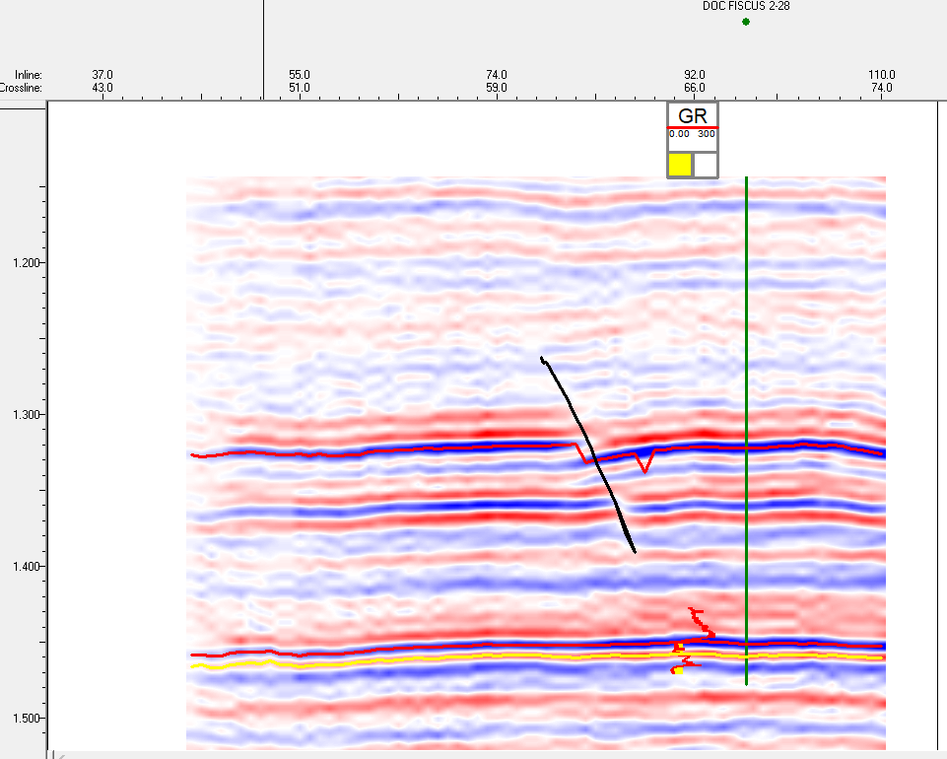

**Figure 1:** “South Fault” pickings at the South part of the survey

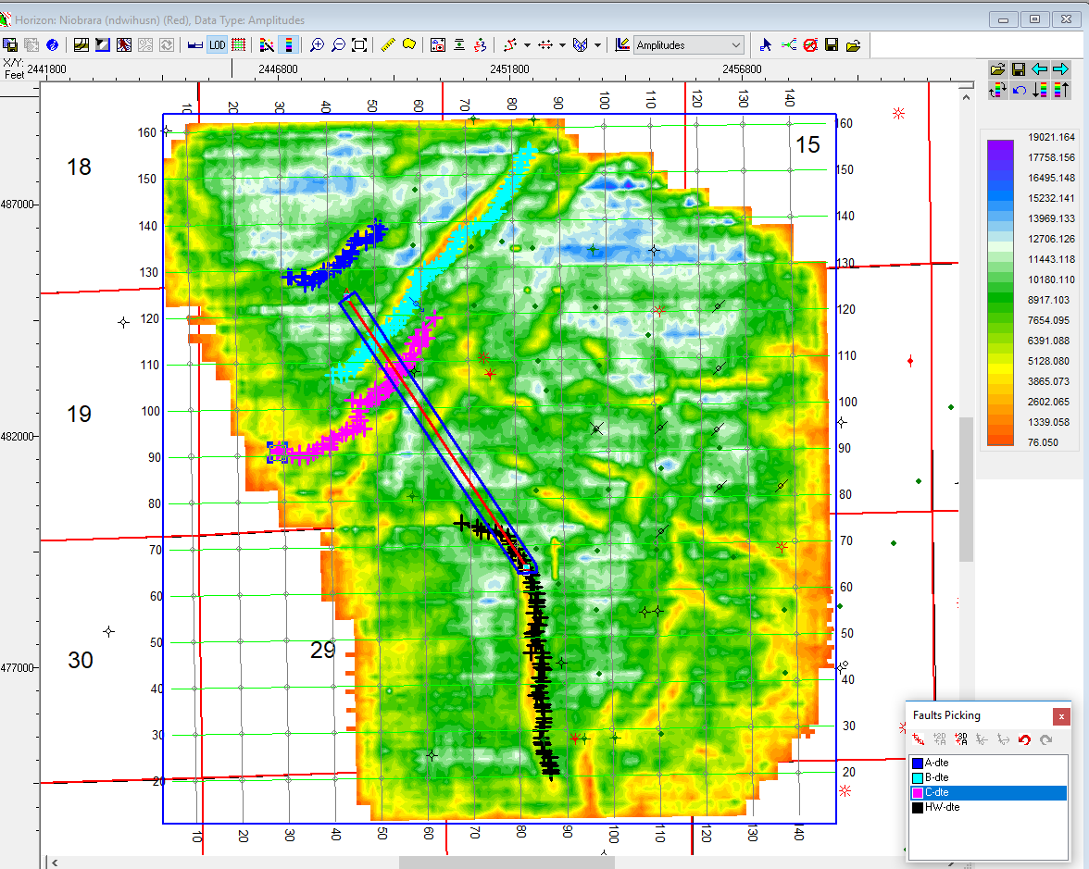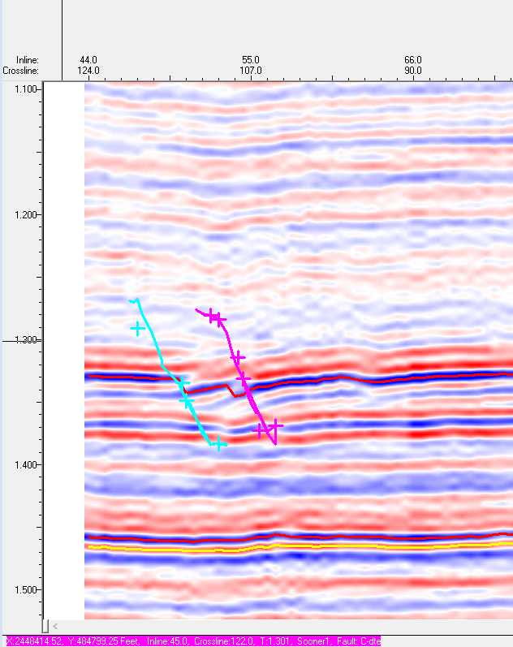

**Figure 2:** “C-dte” fault pickings to the south of “B-dte” fault

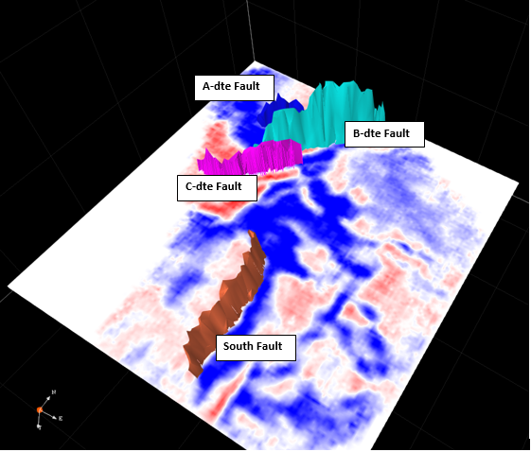

**Figure 3:** 3D visualization of picked faults across 1.3 second time slice

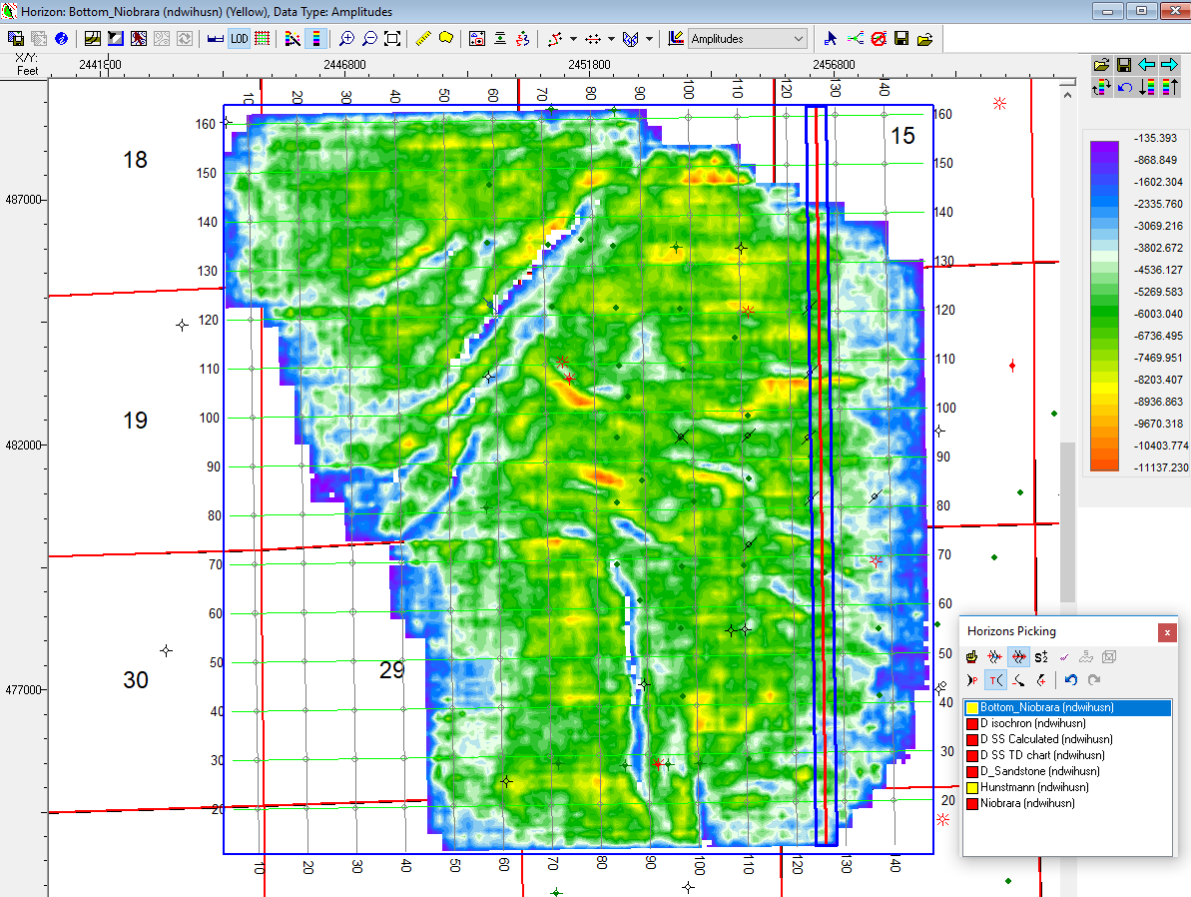

**Figure 4:** Amplitude Map for Bottom of Niobrara 3D Hunt Pick

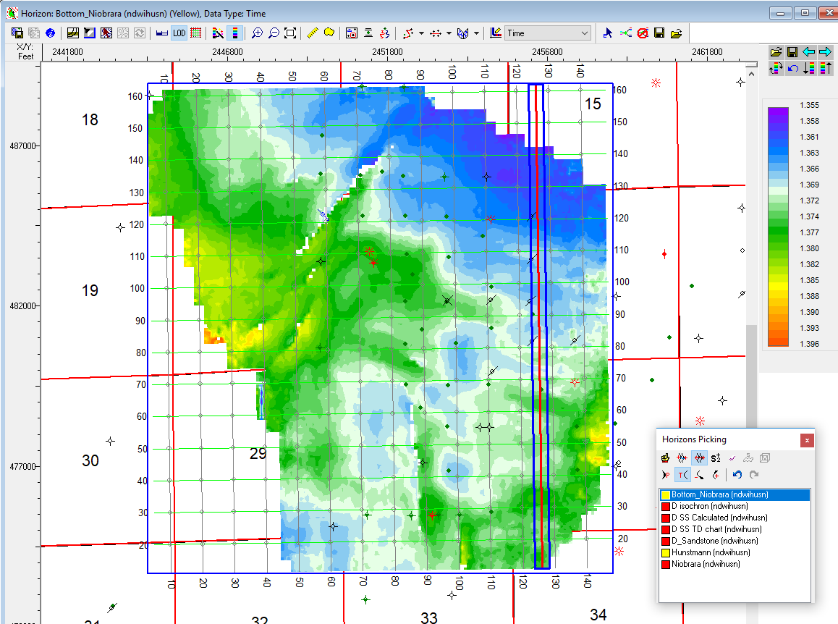

**Figure 5:** Time Map for Bottom of Niobrara 3D Hunt Pick

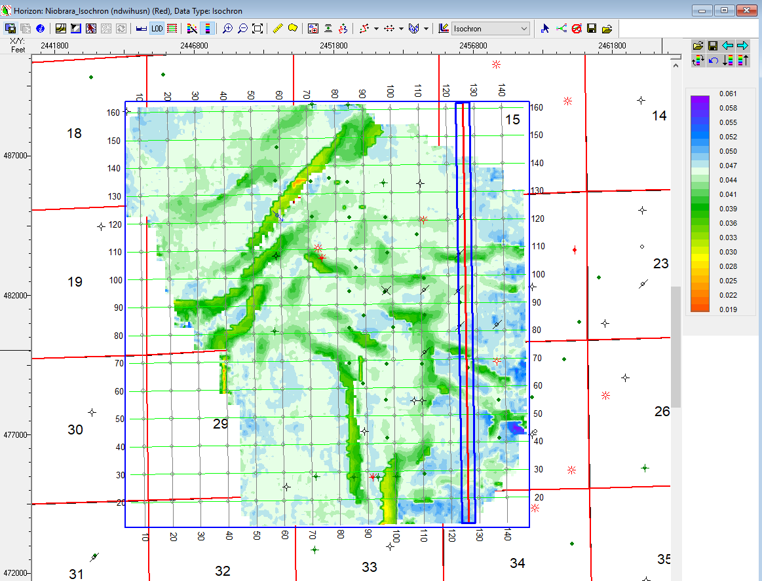

**Figure 6:** Thickness Map from Top to Bottom of Niobrara

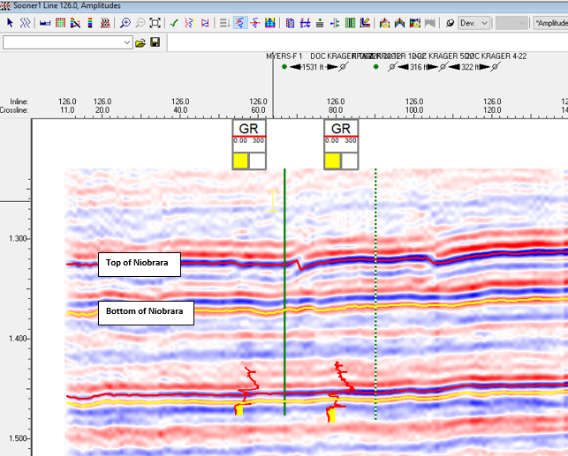

**Figure 7:** Top and Bottom of Niobrara picked horizons